Front end s should cover below things:-

AI Name- Mentioned AI full Name (Legal Name)
Channel:- Mentioned Channel such as Internet/Agent/Business correspondent/Bank Branch etc.

- Integrated page, initial journey
- B Mnemonic logo.
- Category display page
- Bill fetch & Bill payment screen
- Confirmation screen & Bill payment receipt ( B assured logo)
- Complaint raising screen (CMS)
- Confirmation SMS screen.

Integrated page, initial journey
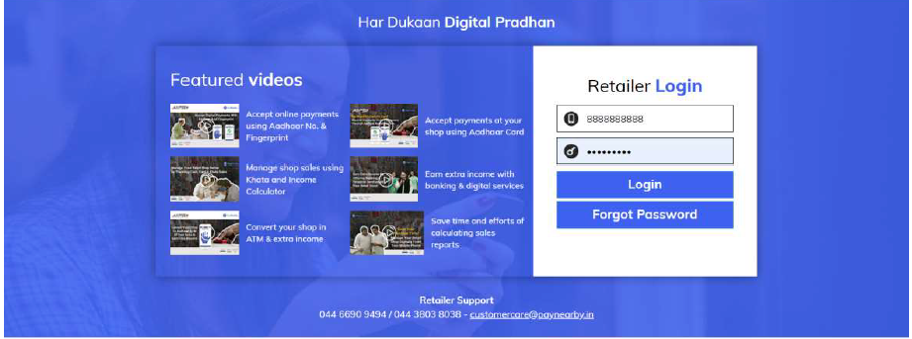

B Mnemonic logo.
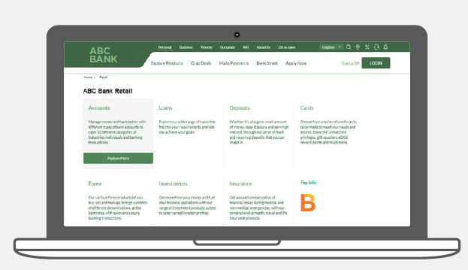
Category display page

Request you to display all BBPS category such as Housing Society, Insurance, Municipal Taxes, Education, Cable TV, Loan Repayment, LPG Gas, Gas, Water, Broadband Postpaid, Landline Postpaid, DTH, Mobile Postpaid, Electricity, Hospital, Municipal Services, Subscription Fees. Don’t show Health, Life Insurance category separately (It should be categories under Insurance)

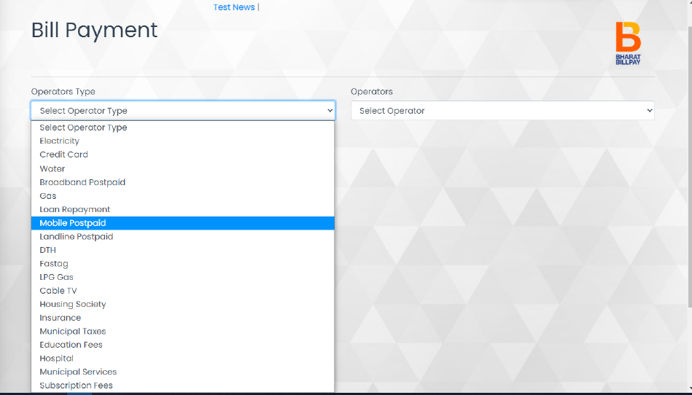

Bill fetch screen

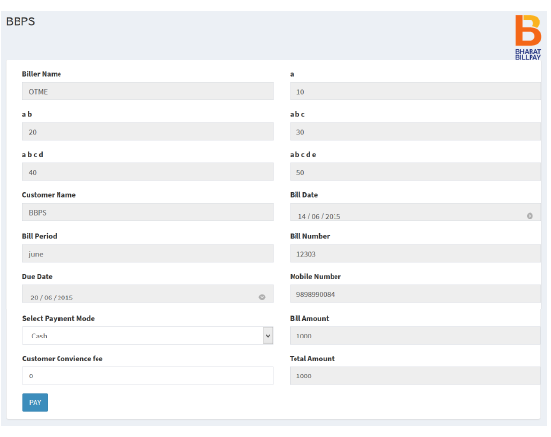

Bill payment screen

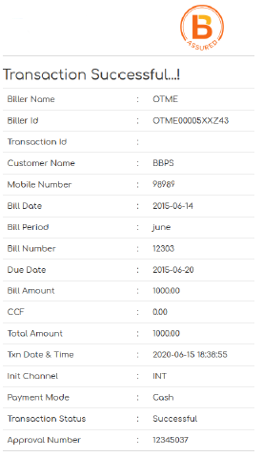
B assured log to implement at top right corner for Internet.

Complaint raising screen (CMS)

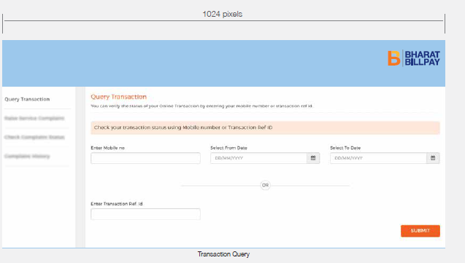

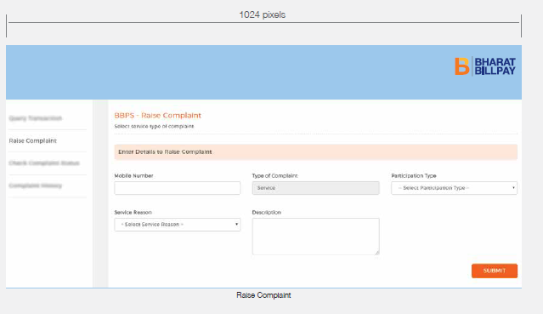

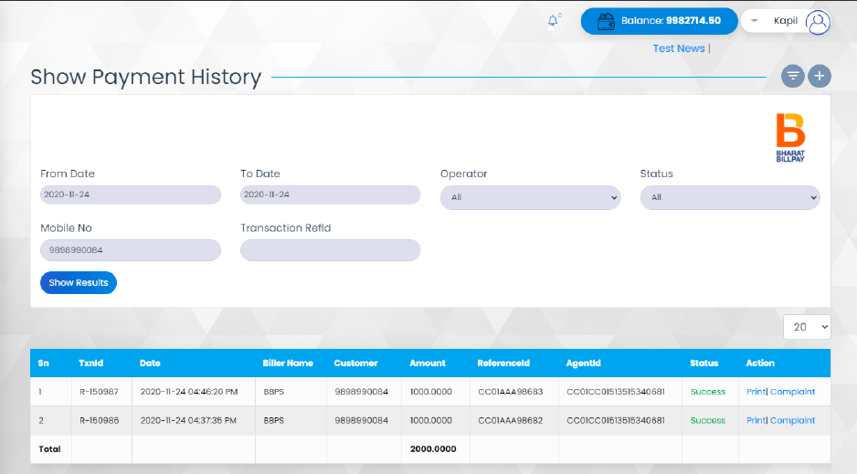
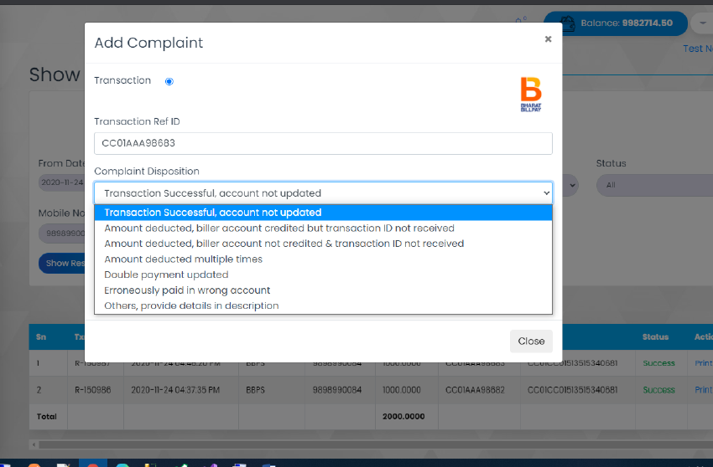
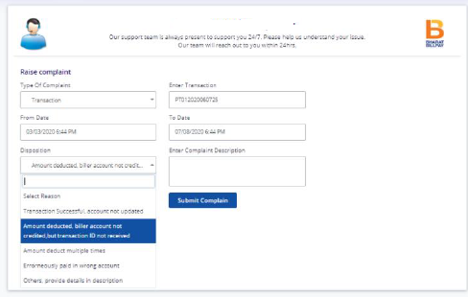

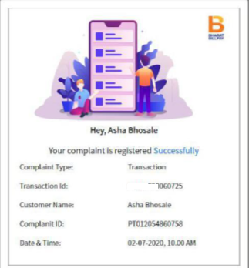
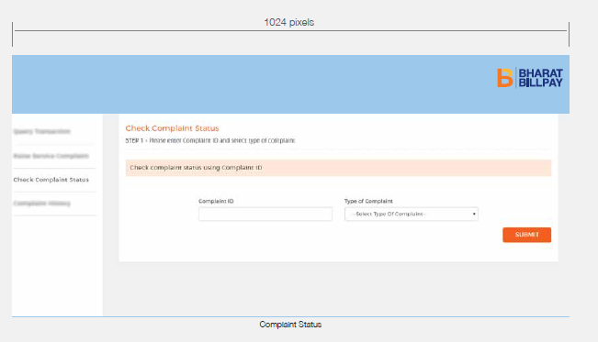

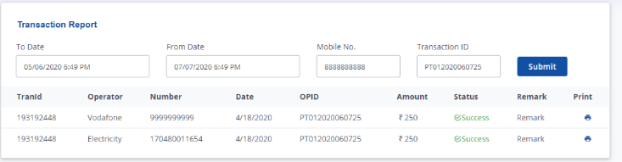

Confirmation SMS screen.

